AD3411 DATA SCIENCE AND ANALYTICS LABORATORY L T P C
0 0 4 2
COURSE OBJECTIVES
∙ To develop data analytic code in python
∙ To be able to use python libraries for handling data
∙ To develop analytical applications using python
∙ To perform data visualization using plots

Tools: Python, Numpy, Scipy, Matplotlib, Pandas, statmodels, seaborn, plotly, bokeh
Suggested Exercises:

1. Working with Pandas data frames
2. Basic plots using Matplotlib
3. Frequency distributions, Averages, Variability
4. Normal curves, Correlation and scatter plots, Correlation coefficient
5. Regression
6. Z-test
7. T-test
8. ANOVA
9. Building and validating linear models
10. Building and validating logistic models
11.Time Series Analysis

HARDWARE:
∙ Standalone Desktops with Windows OS

SOFTWARE:
∙ Python with statistical Packages

Sl.No | List Of Experiments | Pg.No | Signature
1 | Working with Pandas data frame
2 | Basic Plots using Matplotlib
3 | Frequency distributors, Averages, Variability
4 | Normal Curves, Correlation and scatter plots, Correlation coefficient
5 | Regression
6 | Z-test
7 | T-test
8 | Anova
9 | Building and validating linear models
10 | Building and validating logistic models
11 | Time series analysis

EX NO: 1A WORKING WITH NUMPY ARRAYS

NUMPY:
NumPy is a Python library used for working with arrays .It also has functions for working in domain of linear algebra, fourier transform, and matrices. NumPy was created in 2005 by Travis Oliphant. It is an open source project and you can use it freely. NumPy stands for Numerical Python. It is a general-purpose array-processing package.
It provides a high-performance multidimensional array object, and tools for working with these arrays. It is the fundamental package for scientific computing with Python. It contains various features including these important ones:
- A powerful N-dimensional array object
- Sophisticated (broadcasting) functions
- Tools for integrating C/C++ and Fortran code
- Useful linear algebra, Fourier transform, and random number capabilities

AIM
To Write a Python program to demonstrate basic array characteristics.
ALGORITHM
Step1: Start
Step2: Import numpy module
Step3: Print the basic characteristics of array
Step4: Stop

PROGRAM
import numpy as np # Creating array object
arr = np.array( [[ 1, 2, 3], [ 4, 2, 5]] )
# Printing type of arr object
print("Array is of type: ", type(arr))
# Printing array dimensions (axes)
print("No. of dimensions: ", arr.ndim)
# Printing shape of array
print("Shape of array: ", arr.shape)
# Printing size (total number of elements) of array
print("Size of array: ", arr.size)
# Printing type of elements in array
print("Array stores elements of type: ", arr.dtype)

OUTPUT
Array is of type: <class 'numpy.ndarray'>
No. of dimensions: 2
Shape of array: (2, 3)
Size of array: 6
Array stores elements of type: int32

RESULT
Thus the python program working with NumPy array has been implemented and executed successfully.
EX.NO:1B PROGRAM TO PERFORM ARRAY SLICING

AIM
To Write a Python Program to Perform Array Slicing.
ALGORITHM
Step1: Start
Step2: import numpy module
Step3: Create an array and apply the slicing operator
Step4: Print the output
Step5: Stop

PROGRAM
import numpy as np
a = np.array([[1,2,3],[3,4,5],[4,5,6]])
print(a)
print("After slicing")
print(a[1:])

OUTPUT
[[1 2 3]
[3 4 5]
[4 5 6]]
After slicing
[3 4 5] [4 5 6]]

RESULT
Thus the python program working with NumPy array has been implemented and executed successfully.
EX NO: 1C PROGRAM TO PERFORM ARRAY SLICING

AIM
To Write a Python Program to Perform Array Slicing.
ALGORITHM
Step1: Start
Step2: import numpy module
Step3: Create an array and apply the slicing operator
Step4: Print the output
Step5: Stop

PROGRAM
# array to begin with
import numpy as np a = np.array([[1,2,3],[3,4,5],[4,5,6]])
print('Our array is:' )
print(a)
# this returns array of items in the second column
print('The items in the second column are:' )
print(a[...,1]) print('\n' )
# Now we will slice all items from the second row
print ('The items in the second row are:' )
print(a[1,...])
print('\n' ) # Now we will slice all items from column 1 onwards
print('The items column 1 onwards are:' )
print(a[...,1:])

OUTPUT:
Our array is: [[1 2 3] [3 4 5] [4 5 6]]
The items in the second column are: [2 4 5]
The items in the second row are: [3 4 5]
The items column 1 onwards are: [[2 3] [4 5] [5 6]]

RESULT
Thus the python program working with NumPy array has been implemented and executed successfully.
EX NO:2A WORKING WITH PANDAS DATA FRAME

AIM
To Write a program to create a data frame using a list of elements.
ALGORITHM
Step1: Start
Step2: import numpy and pandas module
Step3: Create a data frame using list of elements
Step4: Print the output
Step5: Stop

PROGRAM
import pandas as pd
import pandas as pd
# list of strings
lst = ['A', 'B', 'C', 'D', 'E', 'F', 'G']
# Calling Data Frame constructor on list
df = pd.DataFrame(lst)
print(df)

OUTPUT
0
0 A
1 B
2 C
3 D
4 E
5 F
6 G

RESULT
Thus the python program working with NumPy array has been implemented and executed successfully.

EX NO: 2B CREATE A DATA FRAME USING THE DICTIONARY

AIM
To Write a program to create a dataframe using dictionary of elements.
ALGORITHM
Step1: Start
Step2: import numpy and pandas module
Step3: Create a dataframe using the dictionary
Step4: Print the output
Step5: Stop

PROGRAM
import pandas as pd
# intialise data of lists.
data = {'Name':['Tom', 'nick', 'krish', 'jack'], 'Age':[20, 21, 19, 18]}
# Create DataFrame
df = pd.DataFrame(data)
# Print the output.
print(df)

OUTPUT:
Name Age
0 Tom 20
1 nick 21 0 krish 19 1 jack 18

RESULT
Thus the python program working with NumPy array has been implemented and executed successfully.
EX NO: 2C COLUMN SELECTION

AIM
To Write a program to select a column from dataframe.
ALGORITHM
Step1: Start
Step2: import pandas module
Step3: Create a dataframe using the dictionary
Step4: Select the specific columns and print the output
Step5: Stop

PROGRAM
import pandas as pd
# Define a dictionary containing employee data
data = { 'Name':['kavin', 'shree','Keerthi','Gokul'],'Age':[27, 24, 22, 32],'Address':['Delhi', 'Kanpur', 'Allahabad', 'Kannauj'],'Qualification':['ME', 'M.Tech', 'M.E', 'Phd']}
# Convert the dictionary into DataFrame
df = pd.DataFrame(data)
print(df)
# select two columns
print(df[['Name', 'Qualification']])

OUTPUT

Name Age Address Qualification
0 kavin 27 Delhi ME
1 shree 24 Kanpur M.Tech
2 Keerthi 22 Allahabad M.E
3 Gokul 32 Kannauj Phd

Name Qualification
0 kavin ME
1 Sree M.Tech
2 Keerthi M.E
3 Gokul Phd

RESULT
Thus the python program working with NumPy array has been implemented and executed successfully.
EX NO: 2D CHECKING FOR MISSING VALUES USING ISNULL() AND NOTNULL()

AIM
To Write a program to check the missing values from the dataframe.
ALGORITHM
Step1: Start
Step2: import pandas module
Step3: Create a dataframe using the dictionary
Step4: Check the missing values using isnull() function
Step5: print the output
Step6: Stop

PROGRAM
# importing pandas as pd
import pandas as pd
# importing numpy as np
import numpy as np
# dictionary of lists
dict = {'First Score':[100, 90, np.nan, 95], 'Second Score': [30, 45, 56, np.nan], 'Third Score':[np.nan, 40, 80, 98]}
# creating a dataframe from list
df = pd.DataFrame(dict)
# using isnull() function
newdf=df.isnull()
print(newdf.to_string())

OUTPUT
First Score Second Score Third Score
0 False False True
1 False False False
2 True False False
3 False True False

RESULT
Thus the python program working with NumPy array has been implemented and executed successfully.
EX NO: 3A BASIC PLOTS USING MATPLOTLIB

AIM
To write a python program to create a simple plot using plot() function.
ALGORITHM
Step1: Define the x-axis and corresponding y-axis values as lists.
Step2: Plot them on canvas using.plot() function.
Step3: Give a name to x-axis and y-axis using .xlabel() and .ylabel() functions.
Step4: Give a title to your plot using .title() function.
Step5: Finally, to view your plot, we use . show() function.
Step6: Stop

PROGRAM
import matplotlib.pyplot as plt
# x axis values
x = [1,2,3]
# corresponding y axis values
y = [2,4,1]
# plotting the points
plt.plot(x, y)
# naming the x axis
plt.xlabel('x - axis')
# naming the y axis
plt.ylabel('y - axis')
# giving a title to my graph
plt.title(‘BASIC PLOTS USING MATPLOTLIB!')
# function to show the plot
plt.show()

OUTPUT

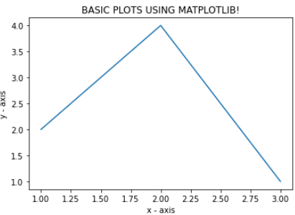

RESULT
Thus the python program working with NumPy array has been implemented and executed successfully.

EX NO: 3B BASIC PLOTS USING MATPLOTLIB

AIM
To write a python program to create a simple plot using plot() function.
ALGORITHM
Step1: Define the x-axis and corresponding y-axis values as lists.
Step2: Plot them on canvas using.plot() function.
Step3: Give a name to x-axis and y-axis using .xlabel() and .ylabel() functions.
Step4: Give a title to your plot using .title() function.
Step5: Finally, to view your plot, we use . show() function.
Step6: Stop

PROGRAM
from matplotlib import pyplot as plt
import numpy as np
import math
x = np.arange(0,math.pi*2,0.05)
y = np.sin(x)
# plotting the points
plt.plot(x, y)
# naming the x axis
plt.xlabel("angle")
# naming the y axis
plt.ylabel("sine")
plt.title('sine curve')
# function to show the plot
plt.show()

OUTPUT

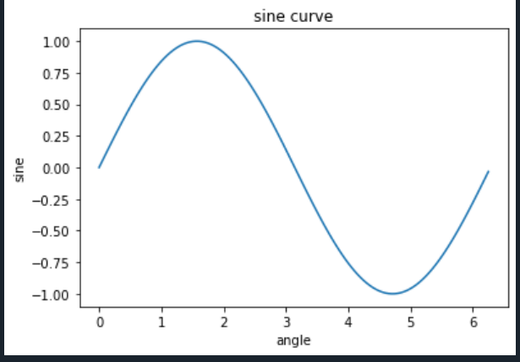

RESULT
Thus the python program to compute X and Y coordinate has been implemented and executed successfully.
EX NO: 4(a) FREQUENCY DISTRIBUTIONS, AVERAGES, VARIABILITY

AIM
To write a python program to create a simple plot using plot() function.
ALGORITHM
Step1: Start
Step2: import pandas module
Step3: Create a data frame using the dictionary and Construct a table using data frame.
Step4: Look for the type of raw data available with you and sort the data using ungrouped or grouped frequency tables.
Step5: Write the values of the data using frequency distribution functions.
Step 6: Stop

Program:
Python program to get frequency distributions
import pandas as pd
#create data
df = pd.DataFrame({'Grade': ['A','A','A','B','B', 'B', 'B', 'C', 'D', 'D'],
'Age': [18, 18, 18, 19, 19, 20, 18, 18, 19, 19],
'Gender': ['M','M', 'F', 'F', 'F', 'M', 'M', 'F', 'M', 'F']})
#view data
print(df)
#find frequency of each letter grade
pd.crosstab(index=df['Grade'], columns='count')

OUTPUT
Grade Age Gender
0 A 18 M
1 A 18 M
2 A 18 F
3 B 19 F
4 B 19 F
5 B 20 M
6 B 18 M
7 C 18 F
8 D 19 M
9 D 19 F

col_0 count
Grade
A 3
B 4
C 1
D 2

RESULT
Thus the python program for frequency distributions has been calculated and executed successfully.

EX NO: 4(b) FREQUENCY DISTRIBUTIONS, AVERAGES, VARIABILITY

AIM
To write a python program to calculate average, variability and standard deviation.
ALGORITHM
Step1: Start
Step2: import Numpy and pandas module
Step3: Create a data frame using the dictionary and Construct a table using data frame.
Step4: Look for the type of raw data available in the list.
Step5: Print the values of average, variability and standard deviation
Step 6: Stop

Python program to get average of a list
# Importing the NumPy module
import numpy as np
# Taking a list of elements
list = [20, 40, 2, 50, 80, 7, 9]
# Calculating average using average()
print(np.average(list))
Python program to get variance of a list
# Importing the NumPy module
import numpy as np
# Taking a list of elements
list = [2, 4, 4, 4, 5, 5, 7, 9]
# Calculating variance using var()
print(np.var(list))
Python program to get standard deviation of a list
# Importing the NumPy module
import numpy as np
# Taking a list of elements
list = [290, 124, 127, 899]
# Calculating standard
# deviation using var()
print(np.std(list))

Output for average of a list :
29.71428
Output variance of a list:
4.0
Output standard deviation of a list:
318.35750344541907

RESULT
Thus the python program for average, variability and standard deviation has been calculated and executed successfully.

EX NO: 5(A) NORMAL CURVES

AIM
To write a python program to create normal curves using plot() function.
ALGORITHM
Step1: Start
Step2: import Numpy and pandas module
Step3: Calculate mean and deviation.
Step4: Calculate normal probability density
Step5: Plot using above calculated values and Display plot
Step 6: Stop

Program:
#Normal curves
import numpy as np
import matplotlib.pyplot as plt
from scipy.stats import norm
import statistics
# Plot between -10 and 10 with .001 steps.
x_axis = np.arange(-20, 20, 0.01)
# Calculating mean and standard deviation
mean = statistics.mean(x_axis)
sd = statistics.stdev(x_axis)
plt.plot(x_axis, norm.pdf(x_axis, mean, sd))
plt.show()

Output:

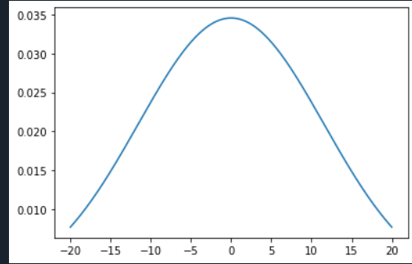

RESULT
Thus the python program normal curve using plot function has been implemented and executed successfully.
EX NO: 5(B) CORRELATION AND SCATTER PLOTS

AIM
To write a python program to create correlation and scatter plots using plot() function.

ALGORITHM
Step1: Start
Step2: import Numpy and pandas module
Step3: Create the data and plot the scatter plot.
Step4: Add the correlation coefficient
Step5: Plot using above calculated values and Display plot
Step 6: Stop.

PROGRAM
#Correlation and scatter plots
import sklearn
import numpy as np
import matplotlib.pyplot as plt
import pandas as pd
y = pd.Series([1, 2, 3, 4, 3, 5, 4])
x = pd.Series([1, 2, 3, 4, 5, 6, 7])
correlation = y.corr(x)
print(correlation)
# adds the title
plt.title('Correlation')
# plot the data
plt.scatter(x, y)
# fits the best fitting line to the data
plt.plot(np.unique(x),
np.poly1d(np.polyfit(x, y, 2))
(np.unique(x)), color='red')
# Labelling axes
plt.xlabel('x axis')
plt.ylabel('y axis')

Output:
0.8603090020146067

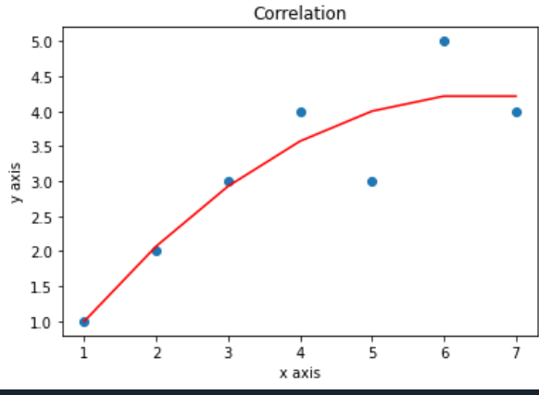

EX NO: 5(C) CORRELATION COEFFICIENT

AIM
To write a python program to calculate correlation coefficient using plot() function.
ALGORITHM
Step1: Start
Step2: import Numpy and pandas module
Step3: Calculate the correlation coefficient using declared values.
Step4: Add the correlation coefficient
Step5: Plot using above calculated values and Display plot
Step 6: Stop.

# Correlation coefficient
# Python Program to find correlation coefficient.
from numpy.random import randn
from numpy.random import seed
from scipy.stats import pearsonr
seed(1)
data1=20*randn(1000)+100
data2=data1+(10*randn(1000)+50)
corr,_=pearsonr(data1,data2)
print('Pearson correlation:%3f'%corr)

Output:
Pearson correlation:0.887612

RESULT
Thus the python program multiple line using plot function has been implemented and executed successfully.
EX NO: 6 REGRESSION

AIM
To write a python program to calculate correlation coefficient using Stats models function.

ALGORITHM
Step1: Start
Step2: import Numpy, Stats models library and pandas module
Step3: Define Y and X matrices and add a constant column to the X matrix.
Step4: the model parameters using the data set (fit the line)
Step5: Display the results
Step 6: Stop.

Program:
import numpy as np
import matplotlib.pyplot as plt
def estimate_coef(x, y):
# number of observations/points
n = np.size(x)
# mean of x and y vector
m_x = np.mean(x)
m_y = np.mean(y)
# calculating cross-deviation and deviation about x
SS_xy = np.sum(y*x) - n*m_y*m_x
SS_xx = np.sum(x*x) - n*m_x*m_x
# calculating regression coefficients
b_1 = SS_xy / SS_xx
b_0 = m_y - b_1*m_x
return (b_0, b_1)
def plot_regression_line(x, y, b)
:# plotting the actual points as scatter plot
plt.scatter(x, y, color = "m",marker = "o", s = 30)
# predicted response vector
y_pred = b[0] + b[1]*x
# plotting the regression line
plt.plot(x, y_pred, color = "g")
# putting labelsplt.xlabel('x')
plt.ylabel('y')
# function to show plot
plt.show()
def main():
# observations / data
x = np.array([0, 1, 2, 3, 4, 5, 6, 7, 8, 9])
y = np.array([1, 3, 2, 5, 7, 8, 8, 9, 10, 12])
# estimating coefficients
b = estimate_coef(x, y)
print("Estimated coefficients:\nb_0 = {} \\nb_1 = {}".format(b[0], b[1]))
# plotting regression line
plot_regression_line(x, y, b)
if __name__ == "__main__":
main()

Output:
Estimated coefficients:
b_0 = -0.0586206896552
b_1 = 1.45747126437

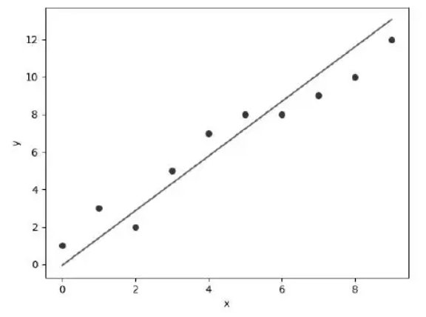

RESULT
Thus the python program to calculate correlation coefficient using Stats models function has been implemented and executed successfully.
EX NO: 7 Z-TEST
AIM
To write a python program to create one Sample Z- Test and two samples Z-Test using Stats models function.

ALGORITHM
Step1: Start
Step2: import Stats models module
Step3: Gather the sample data.
Step4: Define the hypotheses and calculate the z test statistic.
Step5: Calculate the p-value of the z and display the results
Step 6: Stop.

Program: One Sample Z-Test
from statsmodels.stats.weightstats import ztest as ztest
#enter IQ levels for 20 patients
data = [88, 92, 94, 94, 96, 97, 97, 97, 99, 99,
105, 109, 109, 109, 110, 112, 112, 113, 114, 115]
#perform one sample z-test
ztest(data, value=100)

Program Two Sample Z-Test
from statsmodels.stats.weightstats import ztest as ztest
#enter IQ levels for 20 individuals from each city
cityA = [82, 84, 85, 89, 91, 91, 92, 94, 99, 99,
105, 109, 109, 109, 110, 112, 112, 113, 114, 114]
cityB = [90, 91, 91, 91, 95, 95, 99, 99, 108, 109,
109, 114, 115, 116, 117, 117, 128, 129, 130, 133]
#perform two sample z-test
ztest(cityA, cityB, value=0)

Output: One Sample Z-Test
(1.5976240527147705, 0.1101266701438426)

Output: Two Sample Z-Test
(-1.9953236073282115, 0.046007596761332065)

RESULT
Thus the python program for Z-Test has been implemented and executed successfully.

EX NO: 8 T-TEST

AIM
To write a python program to create one Sample Z- Test and two samples Z-Test using Stats models function.

ALGORITHM
Step 1: Start
Step 2: import Stats models module
Step 3: Define hypotheses (null and alternative) State the following hypotheses for significance level =0.05
Step 4: Create two dependent sample groups and Conduct the test.
Step 5: Check criteria for rejecting the null hypothesis
Step 6: Display the results
Step 7: Stop.

Program:
# Importing the required libraries and packages
import numpy as np
from scipy import stats
# Defining two random distributions
# Sample Size
N = 10
# Gaussian distributed data with mean = 2 and var = 1
x = np.random.randn(N) + 2
# Gaussian distributed data with mean = 0 and var = 1
y = np.random.randn(N)
# Calculating the Standard Deviation
# Calculating the variance to get the standard deviation
var_x = x.var(ddof = 1)
var_y = y.var(ddof = 1)
# Standard Deviation
SD = np.sqrt((var_x + var_y) / 2)
print("Standard Deviation =", SD)
# Calculating the T-Statistics
tval = (x.mean() - y.mean()) / (SD * np.sqrt(2 / N))
# Comparing with the critical T-Value
# Degrees of freedom
dof = 2 * N - 2
# p-value after comparison with the T-Statistics
pval = 1 - stats.t.cdf( tval, df = dof)
print("t = " + str(tval))
print("p = " + str(2 * pval))
## Cross Checking using the internal function from SciPy Package
tval2, pval2 = stats.ttest_ind(x, y)
print("t = " + str(tval2))
print("p = " + str(pval2))

Output:
Standard Deviation = 0.947588899242192
t = 3.8663073192337385
p = 0.001131244980767887
t = 3.866307319233738
p = 0.0011312449807677585

RESULT
Thus the python program T-Test has been implemented and executed successfully.
EX NO: 9 ANOVA

Program:
# Installing the package
install.packages("dplyr")
# Loading the package
library(dplyr)
# Variance in mean within group and between group
boxplot(mtcars$disp~factor(mtcars$gear),
xlab = "gear", ylab = "disp")
# Step 1: Setup Null Hypothesis and Alternate Hypothesis
# H0 = mu = mu01 = mu02 (There is no difference
# between average displacement for different gear)
# H1 = Not all means are equal
# Step 2: Calculate test statistics using aov function
mtcars_aov <- aov(mtcars$disp~factor(mtcars$gear))
summary(mtcars_aov)
# Step 3: Calculate F-Critical Value
# For 0.05 Significant value, critical value = alpha = 0.05
# Step 4: Compare test statistics with F-Critical value
# and conclude test p <alpha, Reject Null Hypothesis

OUTPUT

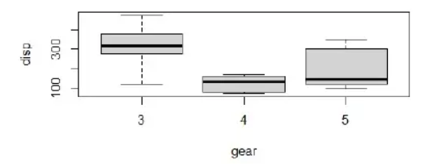

RESULT
Thus the python program multiple line using plot function has been implemented and executed successfully.

EX NO: 10 BUILDING AND VALIDATING LINEAR MODELS

Program
# Importing the necessary libraries
import pandas as pd
import numpy as np
import matplotlib.pyplot as plt
import seaborn as sns
from sklearn.datasets
import load_bostonsns.set(style=”ticks”,color_codes=True)
plt.rcParams[‘figure.figsize’] = (8,5)
plt.rcParams[‘figure.dpi’] = 150
# loading the databoston = load_boston() You can check those keys with the following code.
print(boston.keys())
#The output will be as follow:
dict_keys([‘data’, ‘target’, ‘feature_names’, ‘DESCR’,‘filename’])
print(boston.DESCR)
You will find these details in output:
Attribute Information (in order):
— CRIM per capita crime rate by town
— ZN proportion of residential land zoned for lots over 25,000 sq.ft.
— INDUS proportion of non-retail business acres per town
— CHAS Charles River dummy variable (= 1 if tract bounds river; 0otherwise)
— NOX nitric oxides concentration (parts per 10 million)
— RM average number of rooms per dwelling
— AGE proportion of owner-occupied units built prior to 1940
— DIS weighted distances to five Boston employment centres
— RAD index of accessibility to radial highways
— TAX full-value property-tax rate per $10,000
— PTRATIO pupil-teacher ratio by town
— B 1000 (Bk — 0.63)² where Bk is the proportion of blacks by town
— LSTAT % lower status of the population
— MEDV Median value of owner-occupied homes in $1000’s :MissingAttribute Values: None
df=pd.DataFrame(boston.data,columns=boston.feature_names)
df.head()
# print the columns present in the dataset
print(df.columns)
# print the top 5 rows in the dataset
print(df.head())
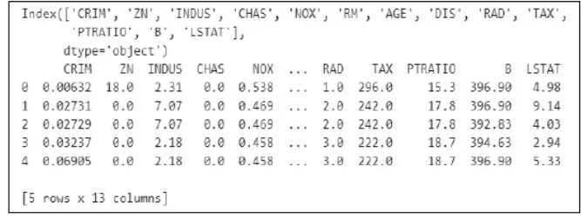
First five records from data set
#plotting heatmap for overall data setsns.heatmap(df.corr(),square=True, cmap=’RdYlGn’)

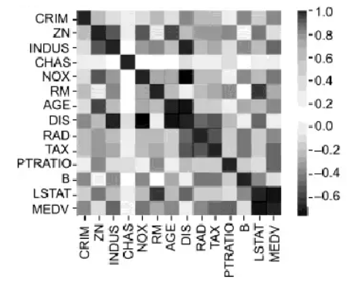

Heat map of overall data set
So let’s plot a regression plot to see the correlation between RM and MEDV. sns.lmplot(x = ‘RM’, y = ‘MEDV’, data = df)
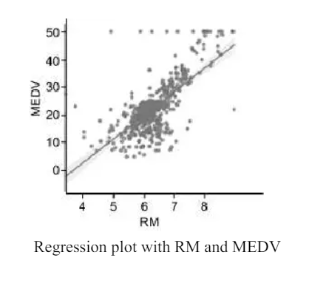

EX NO: 10 BUILDING AND VALIDATING LOGISTICS MODELS

Program
Building the Logistic Regression model:
# importing libraries
import statsmodels.api as sm
import pandas as pd
# loading the training dataset
df = pd.read_csv('logit_train1.csv', index_col = 0)
# defining the dependent and independent variables
Xtrain = df[['gmat', 'gpa', 'work_experience']]
ytrain = df[['admitted']]
# building the model and fitting the data
log_reg = sm.Logit(ytrain, Xtrain).fit()
Output :
Optimization terminated successfully.
Current function value: 0.352707
Iterations 8
# printing the summary table
print(log_reg.summary())

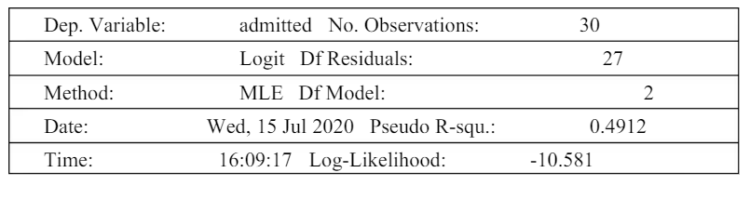

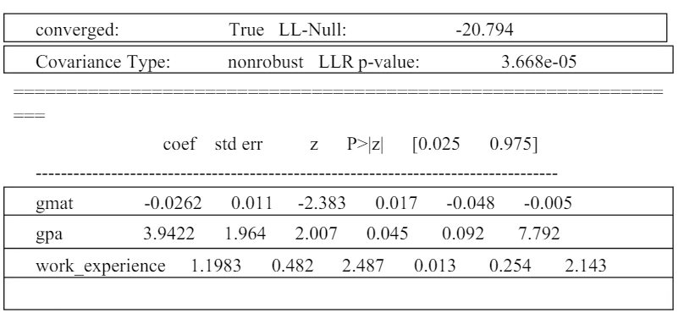

Predicting on New Data :
# loading the testing dataset
df = pd.read_csv('logit_test1.csv', index_col = 0)
# defining the dependent and independent variables
Xtest = df[['gmat', 'gpa', 'work_experience']]
ytest = df['admitted']
# performing predictions on the test dataset
yhat = log_reg.predict(Xtest)
prediction = list(map(round, yhat))
# comparing original and predicted values of y
print('Actual values', list(ytest.values))
print('Predictions :', prediction)
Output :
Optimization terminated successfully.
Current function value: 0.352707
Iterations 8Actual values [0, 0, 0, 0, 0, 1, 1, 0, 1, 1]
Predictions : [0, 0, 0, 0, 0, 0, 0, 0, 1, 1]

